**CE5312 River Mechanics Project**

**1. Determine water depth at t=1.5h and t=4h with negative surge**

Initial condition,

$$U_{0}=1m/s$$

$$h_{0}=10m$$

$$c_{0}=\sqrt{gh_{0}}=9.9045m/s$$

Boundary condition,

In the left side,

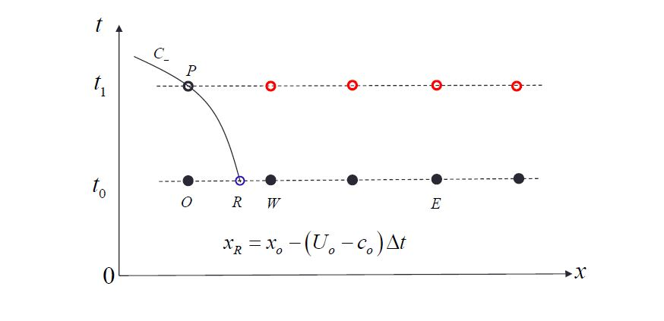

$$h\left(t\right)=h_{0}-at 0<t<1h$$

$$h(t)=9m t>1h$$

$$c\left(t\right)=\begin{matrix}\sqrt{g\left(h_{0}+at\right)} 0<t<1h \\ 9.3963 m/s t>1h \end{matrix}$$

$$U_{R}=U_{o}+\frac{U_{W}-U_{O}}{∆x}x_{R}$$

$$C_{R}=C_{o}+\frac{C_{W}-C_{O}}{∆x}x_{R}$$

$$U_{P}=U_{R}-2\left({C_{P}-C}_{R}\left(t\right)\right)+∆tg(S_{0}-S_{f})$$

In the right side, because we are unknown situations in the right side, hence we assume it remains the same as before.

* Determine slope

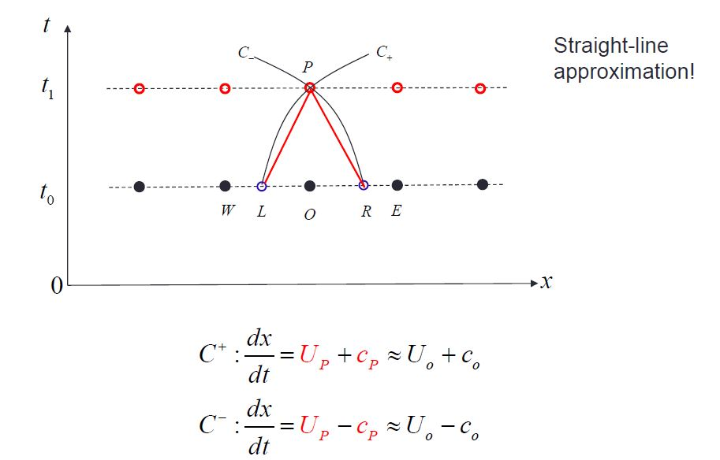

* Evaluate reference points

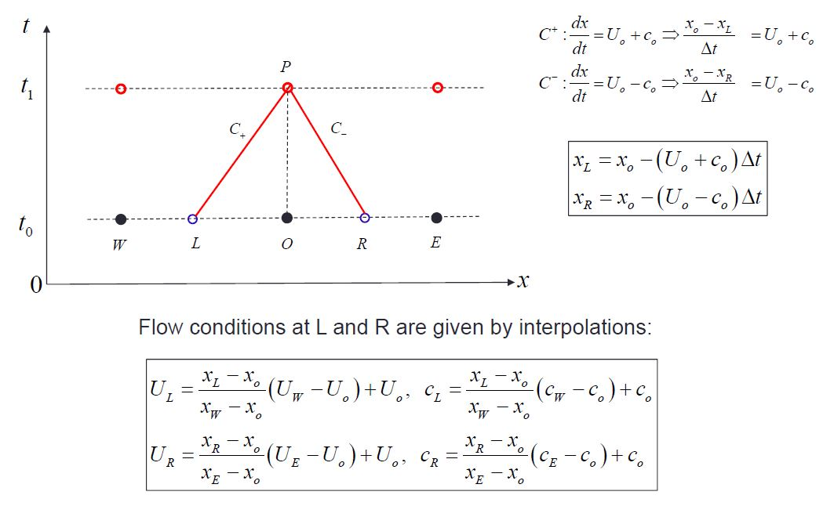

* Calculate source term

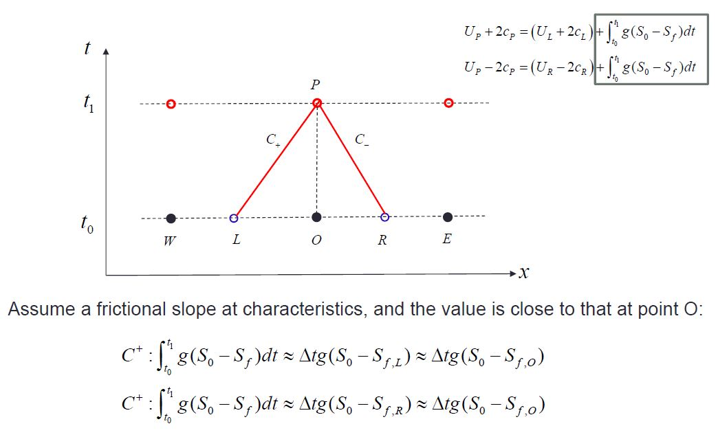

* Final solution

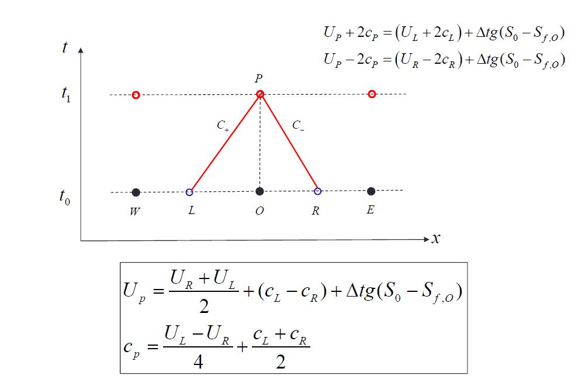

Our numerical parameters are Δx=1000m and Δt=40s with time duration 4 hour and space domain 400km. (Matlab codes are in last chapter Appendix)

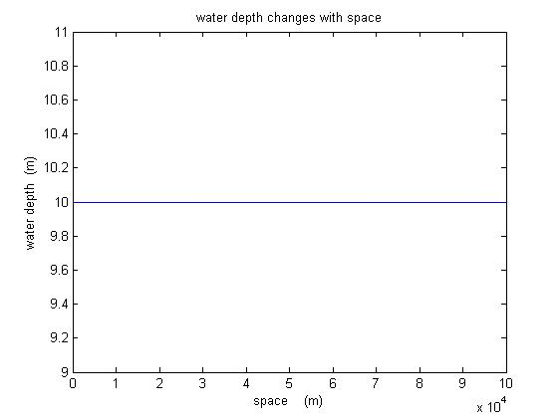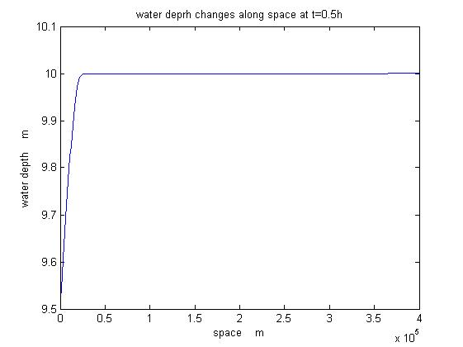

1. t=0 h (b) t=0.5h

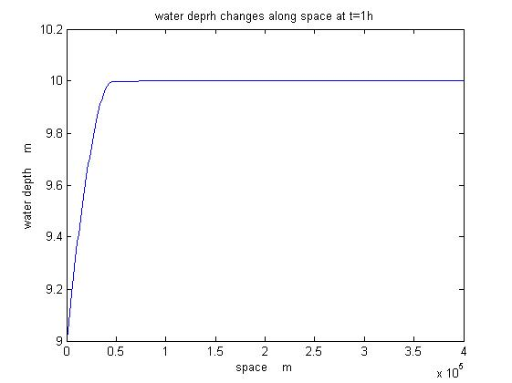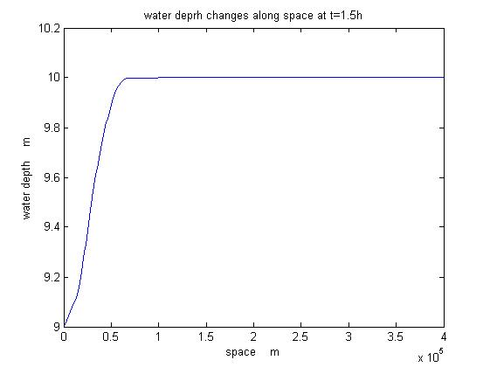

(c) t=1h (d) t=1.5h

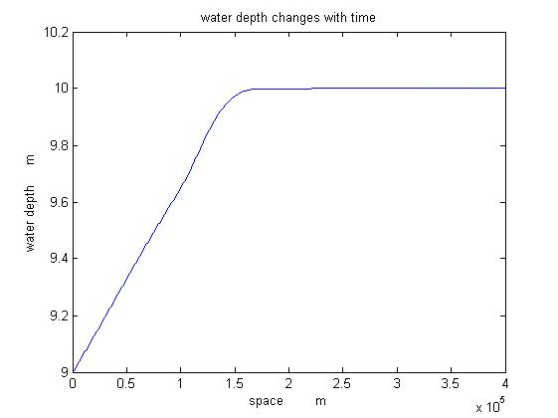

(e) t=4h

Fig.1 Water depth changes with time(negative surge)

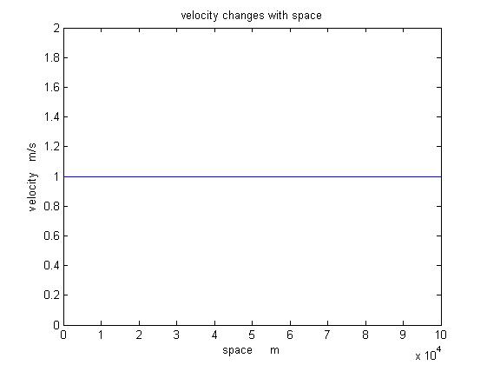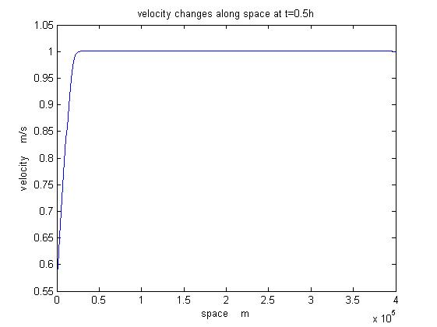

(a) t=0 (b) t=0.5h

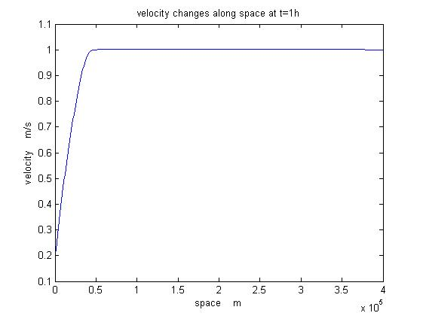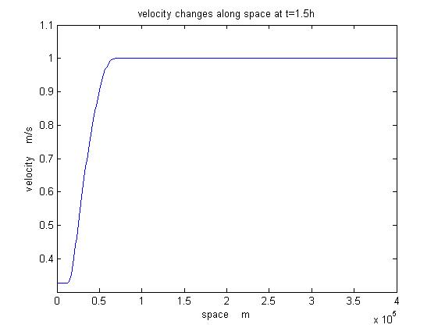

(c) t=1h (d) t=1.5h

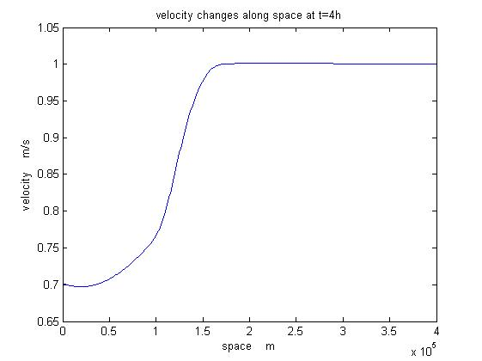

(e) t=4h

Fig.2 Velocity changes with time(negative surge)

**2. Stability test**

Because of numerical solution, our model has stability issues as we discretize both space domain and time domain. According to CLF number, the criterion for stability should follow,

$$\frac{∆x}{∆t}>max⁡|U+C|$$

$$\frac{∆x}{∆t}>max|U-C|$$

We introduce a parameter α to give a weight in order to avoid stability issue and solve it correctly. In the mean time, for negative surge, maximum value occurs in the initial time because celerity and velocity are both decreasing with time. hence, we have

$$∆x>α(U_{0}+C_{0})∆t$$

Once we set time step as 0.001 h, then space step should be greater than 0.011 km.

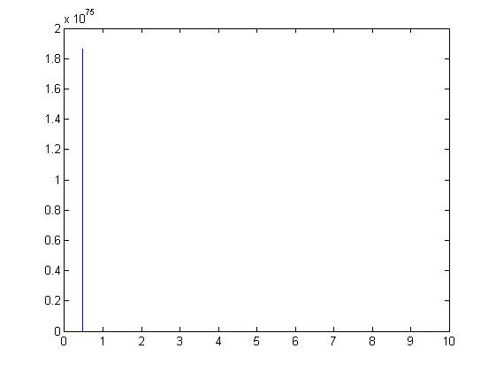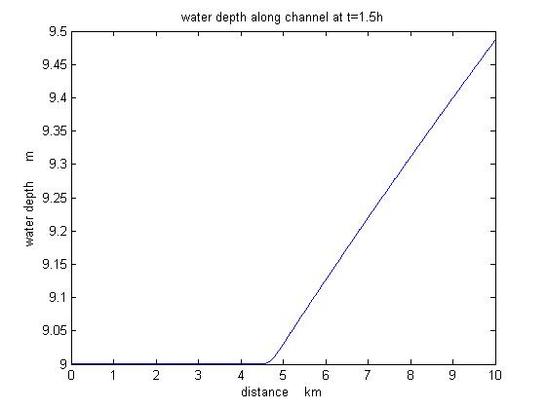

(a) Δx=0.01 km (b) Δx=0.012 km

Fig.3 Stability test

As shown above, when choose Δx=0.01, the solution blows up and even can not display any numbers at final time step whereas when Δx=0.012, it is stable.

Thus, decreasing time step or space step makes contribution to less error and more stability while adding more burden on computer and takes longer computational time. the choice of numerical parameter depends on our objective.

**3. Accuracy**

Error comes from two parts. One is round-off error because computer automatically round-off results and the other is truncation error due to numerical schemes.

According to whole process, this scheme is first order accurate because when approximate slope, we use Euler’s forward method to evaluate.

Truncation error can be reduced by refining the grid whereas round-off error would increase. Basically there is a trade-off and exist an optimal time step to improve this scheme.

**4. Neglecting bottom slope and bottom friction in negative surge**

Theoretically, when neglecting bottom slope and friction, this problem becomes simple wave problem and can be solved by mathematical analysis.

Along C- line, when t=1h

$$U_{1}-2C_{1}=U_{0}-2C_{0}=-18.809m/s$$

$$U_{1}=2C_{1}-18.809=-0.0164m/s$$

Numerically, delete friction and slope term inside the codes.

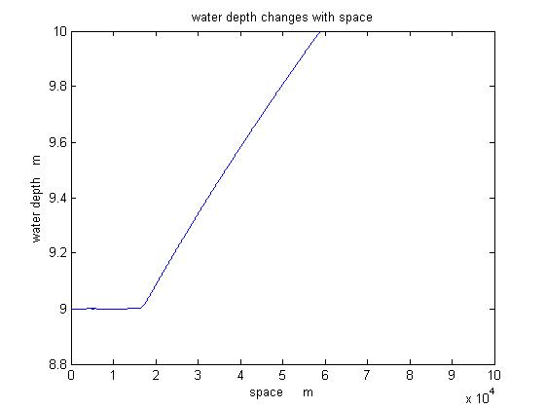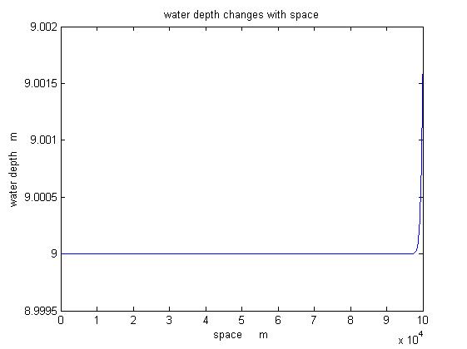

1. t=1.5h (b) t=4h

fig.4 Water depth varies with space

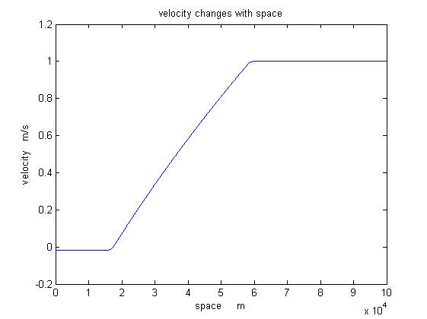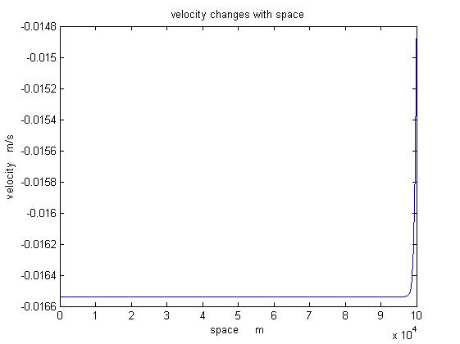

1. t=1.5h (b) t=4h

fig.5 Velocity varies with space

As compare both results, theoretical velocity from time 1 hour onwards should be -0.0164 m/s whereas numerically the result is roughly the same and some error exists because the approximation. That proves this scheme works well.

**5. Positive surge with friction**

For positive surge,

$$h\left(t\right)=h_{0}+at 0<t<1h$$

$$h(t)=11m t>1h$$

$$c\left(t\right)=\begin{matrix}\sqrt{g\left(h_{0}+at\right)} 0<t<1h \\ 10.388 m/s t>1h \end{matrix}$$

Our numerical parameters Δx=100m and Δt=8s with time duration 4 hours and space domain 400km.

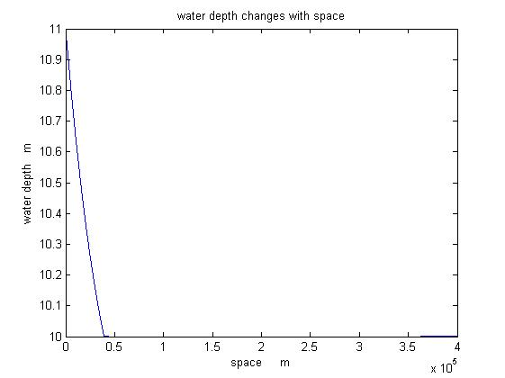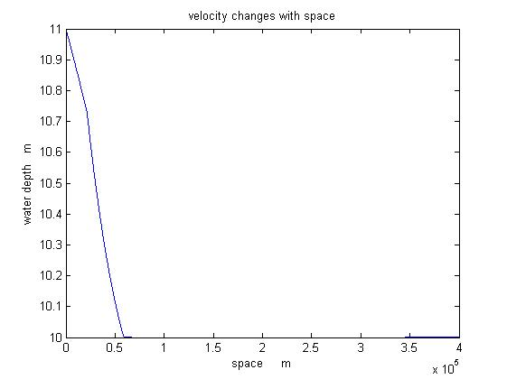

1. t=1h (b) t=1.5h

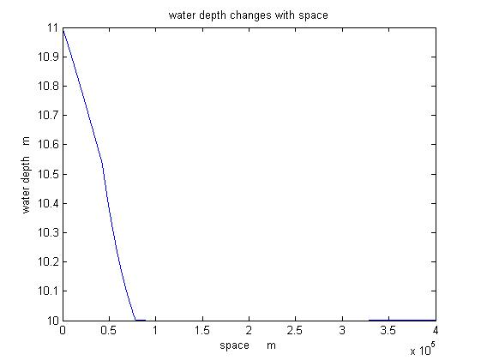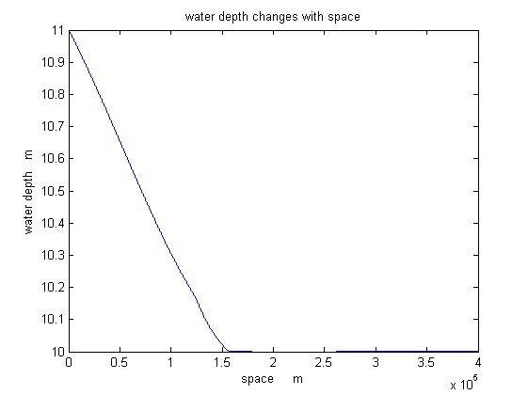

(c) t=2h (c) t=4h

Fig.6 Water depth changes with time (positive surge)

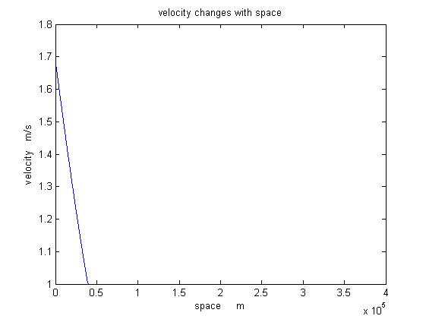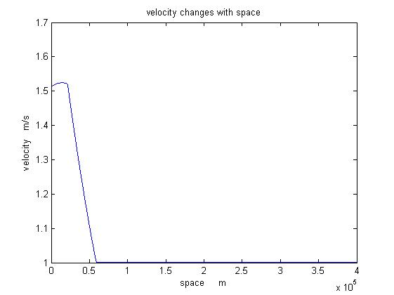

1. t=1h (b) t=1.5h

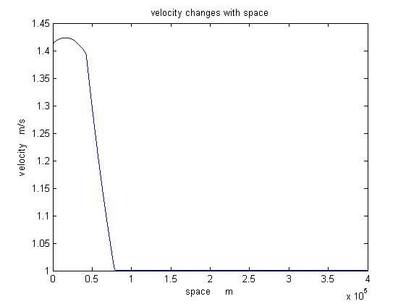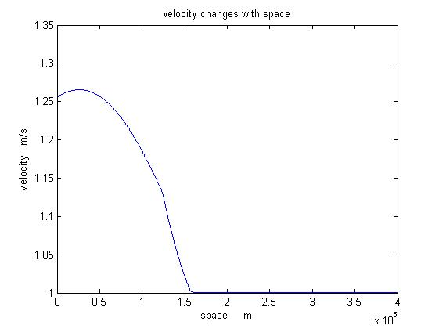

(c) t=2h (d) t=4h

Fig.7 Velocity changes with time (positive surge)

**6. Positive surge without friction**

Similarly, we can evaluate velocity along boundary conditions by theoretically analysis.

Along C- line, when t=1h

$$U_{1}-2C_{1}=U_{0}-2C_{0}=-18.809m/s$$

$$U_{1}=2C_{1}-18.809=1.967m/s$$

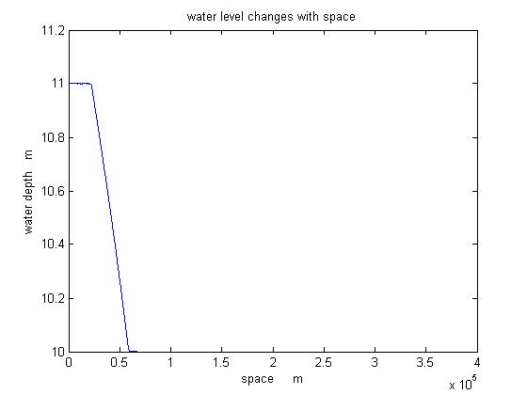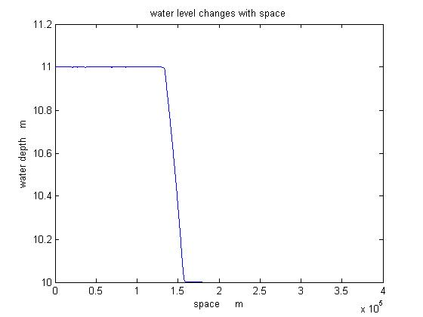

1. t=1.5h (b) t=4h

fig.8 Water depth with no friction

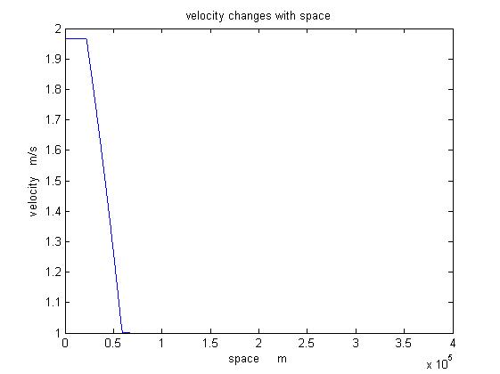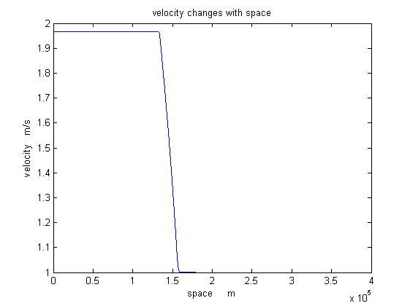

1. t=1.5h (b) t=4h

fig.9 Velocity with no friction

as shown above, numerical solution is close to theoretical solution.

**7.Further discussion**

We change the value of a to 0.5m/h and remain time duration the same.

1. Negative surge

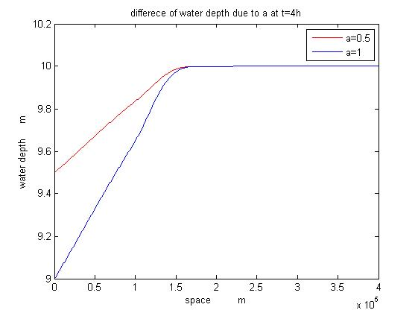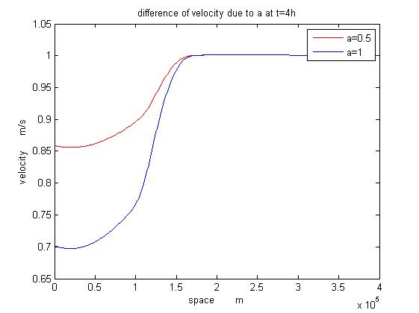

1. Water depth (b) velocity

Fig.10 Comparison of different parameter a

1. Positive surge

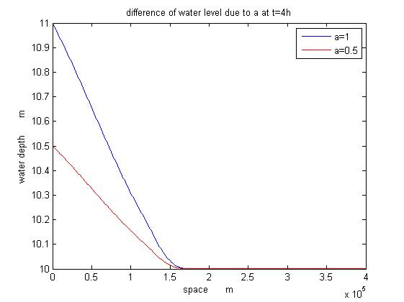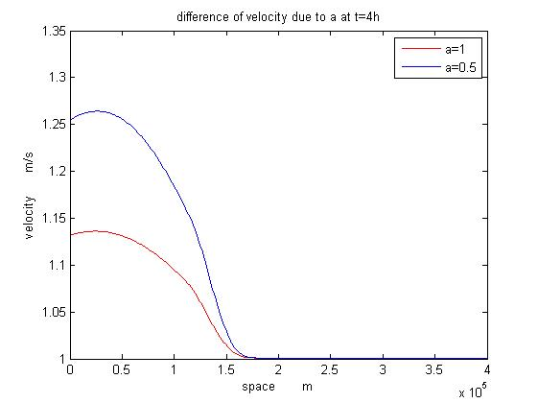

1. Water depth (b) velocity

Fig.11 Comparison of different parameter a

**8. Conclusion**

1. In negative surge, we can always notice that the non-uniform space is becoming broader while in positive surge it is becoming narrower with time. That is because the slope of negative surge diverges while converges for positive.

2. if we change parameter a to 0.5 m/s, the gradient of water depth in negative surge is smaller at final time step and it doesn’t affect the distance of propagation.

3. Comparing numerical solutions and theoretical solutions based on no friction and bottom slope case, negligible difference between them. Thus, we can prove numerical solution works well for 1D non-uniform open channel flow.

4. Comparing surge with and without bottom slope and friction, the difference occurs when boundary water depth remains the same. After that, there has no slope and then follows non-uniform curve without friction. Conversely, the line starts with a straight line firstly and then follows non-uniform curve with friction. Basically, that shows the impact of friction and bottom slope.

**9. Appendix**

Note: here only negative surge codes are shown, for positive, only change sigh of the codes and for non-friction, delete friction and bottom slope term.

clear;

clc;

%------CE5312 Project------%

%define parameters

norm_flow=10; %normal water depth 10 m

v=1; %velocity 1m/s

n=0.02; %manning coefficient

s=1.86*1e-5;%bottom slope

q=norm_flow*v;

dx=50; % unit of x is meter

x=100000;

dt=4; % note unit of t is second

%% negative surge

T=1*3600;

a=1/3600;

%h=norm_flow-a*t when t<T

%h=norm_flow-a*T when t>T

%% when t=1.5 hours

t=4*3600;

%boundary condition (upstream)

time_domain=0:dt:t+dt; %add an imaginary node

n1=t/dt+1; %time nodes

n2=T/dt+1;

n3=x/dx+1; %space nodes

space_domain=0:dx:x+dx; % add an imaginary node

h=zeros(n1,n3);

h(1:n2,1)=norm_flow-a*time_domain(1:n2);

h(n2+1:n1,1)=norm_flow-a*T;

h(1,:)=norm_flow;

%initial condition

c=sqrt(9.81*norm_flow);

v=1;

% form matrix

S1=zeros(n1,n3); %C+ characteristics

S2=zeros(n1,n3); %C- characteristics

U=zeros(n1,n3+1); % add an imaginary node

U(1,:)=v;

C=zeros(n1,n3+1); %add an imaginary node

C(1,:)=c;

C(2:end,1)=sqrt(9.81*h(2:end,1));

U(:,end)=1;

C(:,end)=c;

for j=1:n1-1

for i=1:n3-1

S1(j+1,i+1)=U(j,i+1)+C(j,i+1);

S2(j+1,i+1)=U(j,i+1)-C(j,i+1);

XL(j+1,i+1)=space_domain(i+1)-S1(j+1,i+1)*dt;

XR(j+1,i+1)=space_domain(i+1)-S2(j+1,i+1)*dt;

UL(j+1,i+1)=(XL(j+1,i+1)-space_domain(i+1))/(-dx)*(U(j,i)-U(j,i+1))+U(j,i+1); % because no right hand boundary condition

UR(j+1,i+1)=(XR(j+1,i+1)-space_domain(i+1))/(dx)*(U(j,i+2)-U(j,i+1))+U(j,i+1);

CL(j+1,i+1)=(XL(j+1,i+1)-space_domain(i+1))/(-dx)*(C(j,i)-C(j,i+1))+C(j,i+1);

CR(j+1,i+1)=(XR(j+1,i+1)-space_domain(i+1))/(dx)*(C(j,i+2)-C(j,i+1))+C(j,i+1);

q(j,1)=U(j,1)*h(j,1);

q(j,i+1)=U(j,i+1)*h(j,i+1);

Sf(j,i+1)=(U(j,i+1)*n/(h(j,i+1)^(2/3)))^2;

U(j+1,i+1)=(UL(j+1,i+1)+UR(j+1,i+1))/2+CL(j+1,i+1)-CR(j+1,i+1)+dt*9.81*(s-Sf(j,i+1));

C(j+1,i+1)=(UL(j+1,i+1)-UR(j+1,i+1))/4+(CL(j+1,i+1)+CR(j+1,i+1))/2;

h(j+1,i+1)=C(j+1,i+1)^2/9.81;

end

%left side boundary

Sf_b(j)=(U(j,1)*n/h(j,1)^(2/3))^2;

S_r(j)=U(j,1)-C(j,1);

X_r(j)=space_domain(1)-S_r(j)*dt;

U_r(j)=U(j,1)+(U(j,2)-U(j,1))/dx*X_r(j);

C_r(j)=C(j,1)+(C(j,2)-C(j,1))/dx*X_r(j);

U(j+1,1)=U_r(j)-2*C_r(j)+2*C(j+1,1)+9.81*dt*(s-Sf_b(j));

display(['loading ' ,num2str(j),'/',num2str(n1-1)])

end

for n=1:n1

plot(space_domain(1:end-1),h(n,:))

pause(0.01)

end